Appendix C: Logic Model example 1

Inputs

Staff;

Latino Outreach worker; Coalition Partners; Schools; Funding; Space; Materials

Activities

Youth

- After-school

programs for Latino youth

Families

- Latino community

events

Coalition

- Communicate regularly with Latino community liaison

- Establish positive social norms for Latino population

Outputs
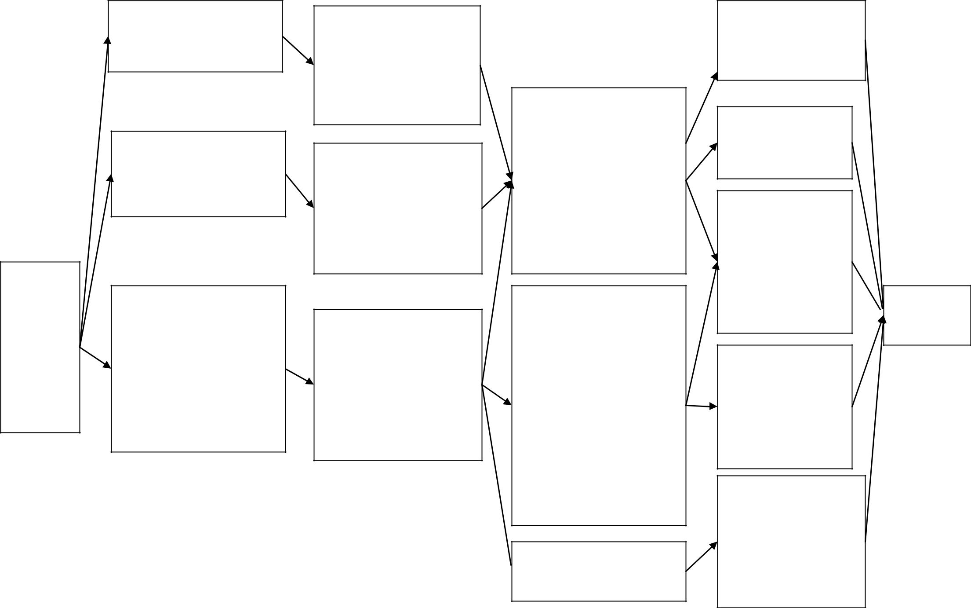

# of youth in program (incl. # of Latino youth)

Frequency of program activities

- of youth who successfully

- of community events

- of materials distributed

- of Latino parents who participate

- of Latino persons active in the coalition

- components/amount of exposure related to social norms media campaign

Short-term outcomes

-Youth, parents, and the community (including Latino families) will increase awareness and knowledge of ATOD use

-Youth increase skills to resist ATOD use and stay ATOD-free

-Latino parents are more involved in ATOD prevention activities

-Latino families have appropriate expectations of home versus school versus the community

-Law enforcement is more aware of cultural issues related to Latino community

Increased knowledge of positive social norms
in community

Intermediate
outcomes

Youth have healthy, ATOD-free environments and relationships

Increased dialogue about underage ATOD use

Parents & community have increased involvement in reducing underage ATOD use (incl. Latino families)

-Reduced youth access to ATOD for youth

-Decreased adult ATOD providers to youth

Change in beliefs of social norms regarding ATOD use; underage ATOD use is uncommon and is not a “right of passage”

Long-term
outcomes

Reduced  underage ATOD use

