2

{Insert Program name and/or priority for Logic Model}

{Insert overall program goal that is reflected in the Logic Model below}

INPUTS |  | STRATEGIES/ |  | OUTPUTS |  | SHORT-TERM |  | INTERMEDIATE |  | LONG-TERM
 |  | ACTIVITIES |  |  |  | OUTCOMES |  | OUTCOMES |  | OUTCOMES
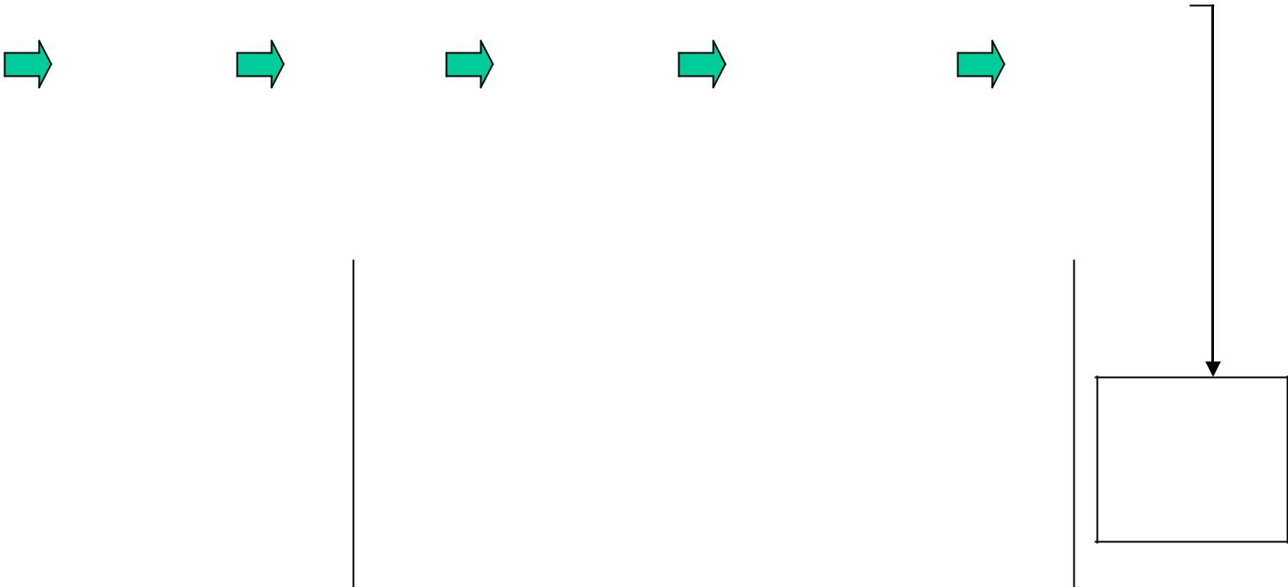

GOAL {Insert overall program goal if not stated above}

Data source to document |  | Insert text |  | Insert text |  | Insert text |  | Insert text
accomplishment |  | here |  | here |  | here |  | here

