Complete Logic Model for Sexual-Violence Priority Area
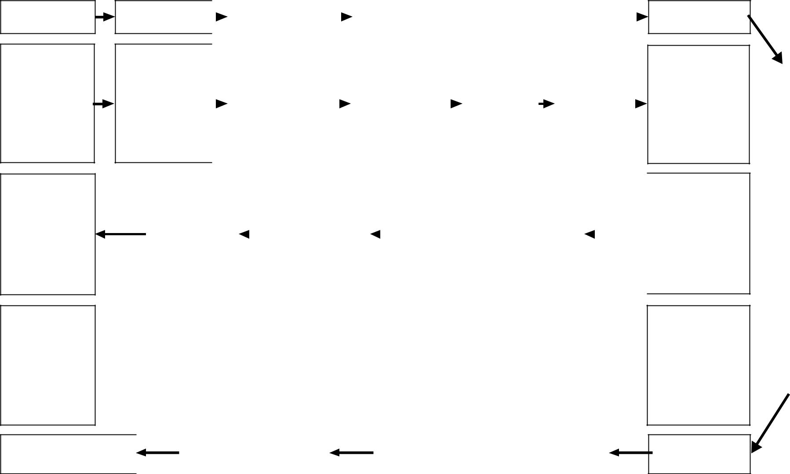

Inputs

Human resources and funding; managerial infrastructure; surveillance and intervention effectiveness data; customer/stakeholder inputs; HHS/CDC priorities

Management

Objective: strengthen planning process

Management

Measure: Relevance review for all intra- and extramural funding streams

Management Objectives (Measures)

 |  | Activities |  |  |  |  |  |  | Outputs |  |  |  |  |  |  |  |  | Customers and Intermediate Outcomes
Develop, test, |  |  |  |  |  |  |  | Program designs; |  |  |  |  |  |  |  | Coalitions; local
 |  |  |  |  |  |  |  | sexual violence–
 | implement, |  |  |  |  |  |  |  |  |  |  |  |  |  |  | rape crisis centers;
 |  |  |  |  |  |  |  |  | prevention
 | evaluate and |  |  |  |  |  |  |  |  |  |  |  |  |  |  |  | community- |  |  |  |  |  | Effective |  |  | Individuals
 |  |  |  |  |  |  |  |  | infrastructure; |  |  |  |  |  |  |  |  |  |  |  |  |  | Effective
monitor state, |  |  |  |  |  |  |  |  |  |  |  |  |  |  |  |  | based centers/ |  |  |  |  |  | sexual |  |  | and groups
 |  |  |  |  |  |  |  |  | education and |  |  |  |  |  |  |  |  |  |  |  |  |  | sexual
 | local, and |  |  |  |  |  |  |  |  |  |  |  |  |  |  |  | NGOs; other |  |  |  |  |  | violence– |  |  | at risk for
 |  |  |  |  |  |  |  | training materials; |  |  |  |  |  |  |  |  |  |  |  |  |  |  | violence–
community-based |  |  |  |  |  |  |  |  |  |  |  |  |  |  |  | federal agencies; |  |  |  |  |  |  | education |  |  | sexual
 |  |  |  |  |  |  |  |  | trained |  |  |  |  |  |  |  |  |  |  |  |  |  | education
sexual violence– |  |  |  |  |  |  |  |  |  |  |  |  |  |  |  |  | state and local |  |  |  |  |  | programs |  |  | violence
 |  |  |  |  |  |  |  | professionals; best |  |  |  |  |  |  |  |  |  |  |  |  |  |  | programs
 | education |  |  |  |  |  |  |  |  |  |  |  |  |  |  | entities; schools;
 |  |  |  |  |  |  |  | practices; technical
 |  | programs |  |  |  |  |  |  |  |  |  |  |  |  |  |  |  | teachers
 |  |  |  |  |  |  |  |  | assistance
 |  |  |  |  |  |  |  |  |  |  |  |  |  |  |  |  |  |  |  |  |  | Intermediate Goal 1.1:
 |  | Annual Goal |  |  |  |  |  |  |  | Annual Goal |  |  |  |  |  |  |  |  |  | Increase knowledge of sexual-
 |  | 1.1.1: |  |  |  |  |  |  |  | 1.1.2: |  |  |  |  |  |  |  |  |  | violence prevention to foster
 |  | Develop, publish, |  |  |  |  |  |  |  | Train high school |  |  |  |  |  |  |  |  |  |  | changes in attitudes and
 |  | and test a pilot |  |  |  |  |  |  |  | teachers to use |  |  |  |  |  |  |  |  |  |  |  | behavior in high school
 |  | rape-prevention |  |  |  |  |  |  |  | the rape- |  |  |  |  |  |  |  |  |  |  |  | communities through
 |  | curriculum for |  |  |  |  |  |  |  | prevention |  |  |  |  |  |  |  |  |  | widespread implementation of
 |  | high schools |  |  |  |  |  |  |  | curriculum |  |  |  |  |  |  |  |  |  |  | effective sexual violence–
 |  |  |  |  |  |  |  |  |  |  |  |  |  |  |  |  |  |  |  |  |  | education programs
 |  |  | Annual
 |  | Measure 1.1.1: |  |  |  |  |  |  |  |  |  |  |  |  |  |  |  |  |  |  | Intermediate Measure 1.1:
 |  | (2007) |  |  |  |  |  |  |  | Annual |  |  |  |  |  |  |  |  |  | (2012)
 |  | n high schools in |  |  |  |  |  |  |  | Measure 1.1.2: |  |  |  |  |  |  |  |  |  | % increase in the number of
 |  | rural, urban, and |  |  |  |  |  |  |  | (2008) |  |  |  |  |  |  |  |  |  | students scoring a B or better
 |  |  | suburban |  |  |  |  |  |  | n teachers are |  |  |  |  |  |  |  |  |  |  |  | after completing rape
 |  | communities |  |  |  |  |  |  |  | trained to use the |  |  |  |  |  |  |  |  |  | prevention–education programs
 |  | have pilot-tested |  |  |  |  |  |  |  | curriculum |  |  |  |  |  |  |  |  |  | in % of high schools in n states
 |  | the published |  |  |  |  |  |  |  |  |  |  |  |  |  |  |  |  |  |  |  | using the curriculum
 |  |  | curriculum
 |  |  |  |  |  | Annual Goals |  |  |  |  |  |  |  |  |  |  |  |  |  |  |  | Intermediate Goals
 |  |  |  |  |  |  | (Measures) |  |  |  |  |  |  |  |  |  |  |  |  |  |  |  | (Measures)
End Outcomes

Prevention of sexual violence

Strategic Goal 1: Reduce the incidence of sexual violence against at-risk individuals and groups through the development and implementation of effective science-based research, surveillance, and prevention programs

Long-Term Measure 1: (2015)

% reduction in the incidence of sexual violence in high school students who have participated in rape-prevention education programs using the curriculum

Strategic Goals

(Measures)

bycausedcostsmedicalandsuffering | disabilityanddeathprematurepreventTo | Mission:
violenceandinjuries | humanthereducetoand

Strategic Planning

External Factors

RAND TR370-2.2

17

